COMSOL, Inc.  100 District Avenue  Burlington, MA 01803 USA  Phone: +1 781-273-3322  Web: www.comsol.com  Blog: www.comsol.com/blogs | Media Contact:  Natalia Switala  PR & Communications Project Manager  natalia@comsol.com

Simulation Apps Pave New Frontier for
Virtual Prototyping of Surface-Mount Devices

BE CAE & Test engineers use the COMSOL Multiphysics® software and the Application Builder
to design electronic device testing simulation apps that provide interactive design capabilities for their customers.

BURLINGTON, MA (March 31, 2016) – Engineers at BE CAE & Test (Catania, Italy) have taken the simulation process well beyond the typical approach of “run a test / deliver a report.” Instead, using the COMSOL Multiphysics® software and the Application Builder, they have created a series of easy-to-use custom applications that perform state-of-the-art virtual prototyping of their customers’ surface-mount device designs. The apps hide the complexity of the underlying detailed model, yet still provide access to the powerful functionality of the simulation.

Thermal management techniques ensure the efficiency of electronic devices, improve reliability, and prevent premature failure. Numerical simulation is an important part of the process, allowing engineers to analyze and optimize temperature and air flow early in the design. BE CAE & Test is creating custom applications to give device designers interactive tools to access, analyze, and share the vast amount of information available from the mathematical models they created without needing app users to be simulation specialists themselves.

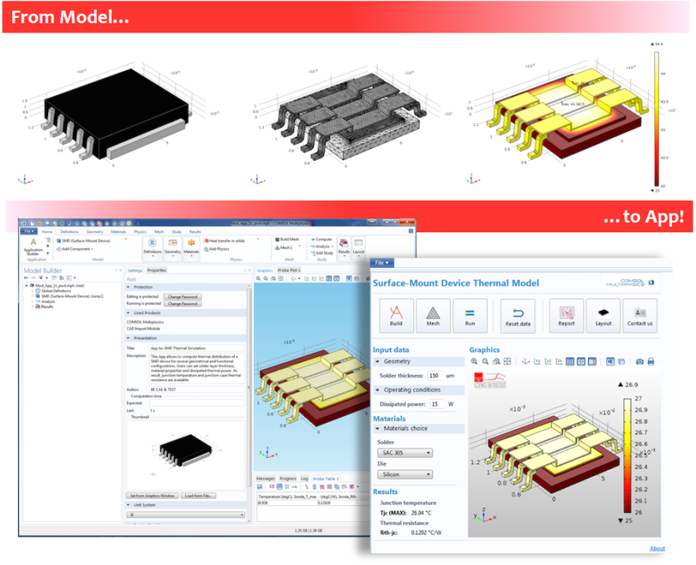

The Application Builder allows BE CAE & Test engineers to turn their COMSOL Multiphysics® software model into a customized application for their customers to use. This simulation app is based on a COMSOL® software model used to conduct a thermal analysis of an electronic device.

Apps Create New Business Opportunities
“Apps mark a revolutionary page in the history of mathematical modeling and numerical simulation,” said Giuseppe Petrone, FEA expert and Co-Founder of BE CAE & Test. “These specialized and user-friendly tools bring the power of numerical simulation to a larger group of users. People with no prior experience from FEA or mathematical modeling can access, exploit, and benefit from analysis. As such, simulation apps can create more business opportunities with customers. Beyond simply providing them with a technical report, you are also supplying them with an interactive tool.”

The app created by BE CAE & Test for surface-mount device designs conducts a thermal analysis that allows users to evaluate a variety of important thermal characteristics. The temperature distribution within the device, maximum temperature reached, junction-to-case thermal resistance as a function of solder thickness, and dissipated power and constitutive material of the solder and the die are among the results presented to the app user.

Interactive Tools that Ensure Accuracy
“Apps offer an innovative way of interacting with customers,” stated Petrone. “Rather than simply sending simulation results to them, you can provide customers with a flexible tool that they can use to investigate the problem on their own — all while ensuring accuracy in their results.”

“’What happens in my system if…,’ is a question that the team at BE CAE & Test typically hears when first meeting with customers,” Petrone continued. “Traditionally, our reply was, ‘Let us build a reference model for your system and then carry out parametrical simulations. We will be able to give you useful predictions, which are an essential advantage to virtual prototyping.’ Now, with the use of simulation apps, we have a much simpler reply, ‘Let us provide you with a COMSOL® software app, and you will be able to check yourself.’”

About BE CAE & Test
The BE CAE & Test engineering team supports companies, researchers, and professionals in the competitive development of products and processes using advanced CAD / CAE and organizing accurate experimental testing tools. The experience gained in the experimental vibro-acoustic measurements, the numerical simulation FEM and Multibody, and deployment of applications for the Multiphysics modeling make BE CAE & Test the ideal partner for reliability, innovation and competitiveness of your products and processes.

About COMSOL
COMSOL is a global provider of simulation software for product design and research to technical enterprises, research labs, and universities. Its COMSOL Multiphysics® product is an integrated software environment for creating physics-based models and simulation apps. A particular strength is its ability to account for coupled or multiphysics phenomena. Add-on products expand the simulation platform for electrical, mechanical, fluid flow, and chemical applications. Interfacing tools enable the integration of COMSOL Multiphysics® simulations with all major technical computing and CAD tools on the CAE market. Simulation experts rely on the COMSOL Server™ product to deploy apps to their design teams, manufacturing departments, test laboratories, and customers throughout the world. Founded in 1986, COMSOL employs more than 400 people in 22 offices worldwide and extends its reach with a network of distributors.

~
COMSOL, COMSOL Multiphysics, Capture the Concept, and COMSOL Desktop are registered trademarks of COMSOL AB. COMSOL Server, LiveLink, and Simulation for Everyone are trademarks of COMSOL AB. Other product or brand names are trademarks or registered trademarks of their respective holders.

