COMSOL, Inc.  1 New England Executive Park  Burlington, MA 01803 USA  Phone: +1 781-273-3322  Web: www.comsol.com  E-mail: info@comsol.com | Media Contact:  Natalia Switala  PR & Communications Project Manager  natalia@comsol.com  Learn more about COMSOL Multiphysics® and the Application Builder at: www.comsol.com/5.1

Peab Asfalt AB Uses Simulation Apps for a Novel Approach to
Test Asphalt Material Properties
Peab Asfalt engineers and technicians use simulation apps created with COMSOL Multiphysics® software and the Application Builder to quickly and efficiently test asphalt material properties.
BURLINGTON, MA (June 2, 2015) Seasons are the perpetual enemy of roads and highways, where changing climates can lead to potholes, cracking, and lots of repairs. Determining if repairs are needed—or even preventing deterioration in the first place—necessitates ample testing of the material properties of asphalt concrete. Peab Asfalt, a subsidiary of the Peab Group and one of Sweden's largest companies specialized in the production and laying of hot, warm, and cold asphalt, is using a newly developed method to test asphalt material properties. Whereas previous testing methods were expensive and time-consuming, this novel approach can be conducted using samples of any size and results are available within hours. The new testing method uses simulation apps created by the R&D department at Peab Asfalt with COMSOL Multiphysics® software and the Application Builder to allow engineers and technicians to independently and efficiently carry out multiple tests.
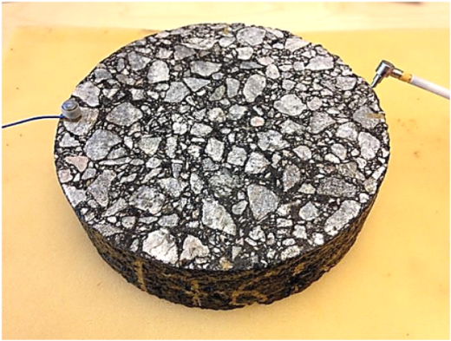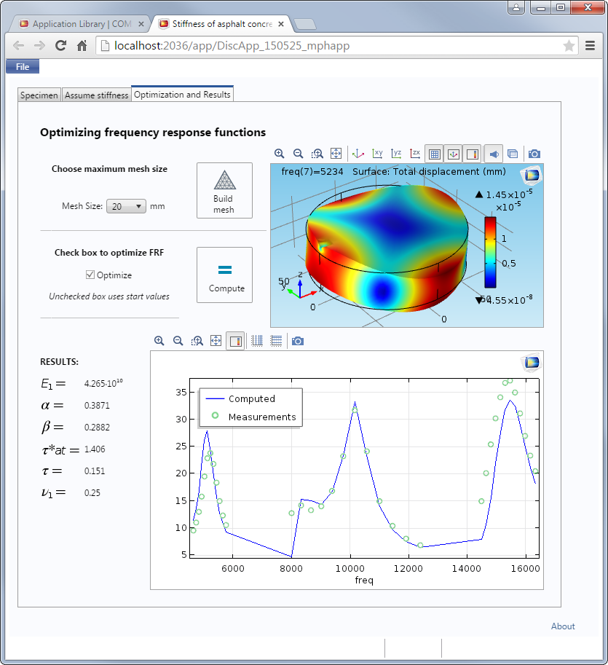
Left: Experimental setup for testing the stiffness of asphalt concrete. Right: Simulation app used to calculate the material’s stiffness. The app reads measurements from experimental tests of asphalt material properties and lets engineers and technicians quickly determine if the material has the ideal stiffness for the environment in which it is being used. The app is shown here being run in a web browser using a COMSOL Server™ license.

Optimizing Asphalt Material Properties
After being exposed to the environment for extended periods of time, the material properties of asphalt can change, making the material more susceptible to deterioration. Additionally, the material properties are temperature dependent. “In cold weather, asphalt concrete that is too stiff can lead to cracking and degradation,” said Anders Gudmarsson, R&D Manager at Peab Asfalt. “In warmer temperatures, on the other hand, asphalt with too much flexibility can lead to permanent deformation.” To design asphalt that can withstand varying temperatures and that is best suited for a specific environment, engineers must take into account the viscoelastic dynamic Young’s modulus of the asphalt, a measurement used to describe the material’s stiffness.

Conventional methods for determining stiffness and other material properties involve lengthy and expensive physical testing, where cyclic loading is applied to an asphalt sample and deformations are measured. However, Gudmarsson has developed a new testing method that uses mechanical resonance frequency measurements and numerical calculations as a way to determine stiffness. The method is the result of Gudmarsson’s PhD project, which was supervised by Nils Ryden, Head of section Peab Grundteknik and R&D at Peab Anläggning, and funded and supported by the Swedish Transport Administration, the Development Fund of the Swedish Construction Industry (SBUF), KTH Royal Institute of Technology, and Peab Asfalt.

“We wanted to make this technique available on a wider scale in a way that would allow laboratory technicians to make decisions based on the results,” said Gudmarsson. “With COMSOL Multiphysics and the Application Builder, we were able to deliver on this using the integrated COMSOL® software environment to create a simulation app that digests the measured results and returns useable data. Most importantly, we were able to design the app so that it can be used by anyone, even those without simulation expertise.”

During the frequency response test, resonance measurements are taken on an asphalt sample to find the material’s dynamic response. The sample used in the test can be of any size or shape, which makes the test both easier and faster when compared with previous methods. After the experimental test, measurements are read by the simulation app, where the stiffness—in this case, the dynamic modulus—of the asphalt is computed for a wide range of frequencies. The simulation app works with frequency response curves and determines the material properties of the asphalt being tested.

“Stiffness testing of asphalt concrete was possible before, but conventional test methods were expensive, complicated, and time-consuming to perform,” says Gudmarsson. “Our new method is much more economical and the availability of a simulation app for optimizing the findings means that any engineer can easily take advantage of it. We can definitely see great potential for the broader use of simulation apps within the whole company.

About Peab
Peab is one of the Nordic region's leading construction and civil engineering companies with 13,000 employees and about SEK 43 billion in net sales. The Group’s subsidiaries have strategically located offices in Sweden, Norway and Finland. Peab Asfalt is a subsidiary within the Peab Group and is one of Sweden's largest specialized companies within production and laying of hot, warm and cold asphalt.

About COMSOL
COMSOL provides simulation software for product design and research to technical enterprises, research labs, and universities through 22 offices and a distributor network throughout the world. Its flagship products, COMSOL Multiphysics® and COMSOL Server™, are software environments for modeling and simulating any physics-based system and for building and distributing applications. A particular strength is its ability to account for coupled or multiphysics phenomena. Add-on products expand the simulation platform for electrical, mechanical, fluid flow, and chemical applications. Interfacing tools enable the integration of COMSOL Multiphysics simulation with all major technical computing and CAD tools on the CAE market.
~
COMSOL, COMSOL Multiphysics, COMSOL Server, and LiveLink are either registered trademarks or trademarks of COMSOL AB. Other product or brand names are trademarks or registered trademarks of their respective holders.

