COMSOL, Inc.  1 New England Executive Park  Burlington, MA 01803 USA  Phone: +1 781-273-3322  Web: www.comsol.com  E-mail: info@comsol.com | Media Contact:  Natalia Switala  PR & Communications Project Manager  Natalia@comsol.com  Learn more about COMSOL 5.1, Application Builder,  and COMSOL Server™ at: www.comsol.com/5.1

Cypress Semiconductor Streamlines Touchscreen Design
with the Application Builder and COMSOL Server™

Cypress Semiconductor, the leading supplier of touchscreen and embedded systems, augments their R&D, sales, and customer support departments with the use of simulation apps.

BURLINGTON, MA (April 29, 2015) R&D engineers at Cypress are creating simulation apps that streamline their touchscreen design processes. Cypress Semiconductor Corp. is the leading supplier of smartphone touchscreen and touch-sensing solutions. Their simulation engineers are now sharing their simulation expertise with colleagues using the Application Builder and COMSOL Server™, released with COMSOL Multiphysics® simulation software version 5. With the Application Builder, engineers are creating ready-to-use simulation applications that can be used across departments, including by product development, sales, and customer service. The Application Builder provides simulation experts with the ability to build intuitive simulation apps based on their models directly within the COMSOL environment, and COMSOL Server lets them share these apps with colleagues and customers around the globe. This integrated app design environment is a first within the world of modeling and simulation.

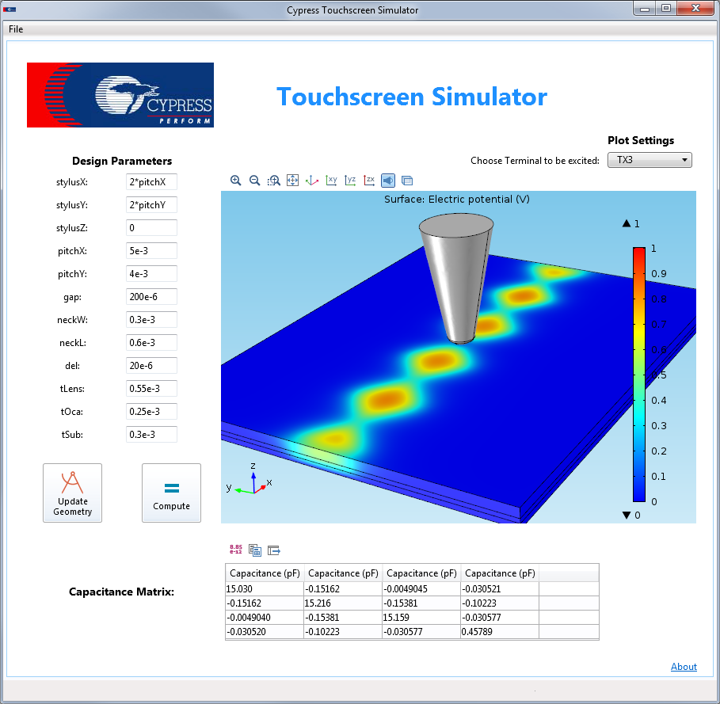
Simulation app based on a COMSOL model used to support the design of touch-based capacitive sensors. The finger or stylus touching the panel is represented by a conical structure. The user can change design parameters ranging from the finger location to the thickness of the different layers in the sensor. The app generates a report detailing the capacitance matrix, an integral piece of information for capacitive sensor design, and shows the voltage distribution in the sensor. A drop-down list can be used to select a solution corresponding to the excitation of different sensor traces.

Simulation Apps Improve R&D at Cypress
To incorporate cutting-edge advances into touchscreen technology and embedded system products, simulation engineers at Cypress use COMSOL for research and design initiatives. Their touchscreens are used in phones and mp3 devices, automotive and industrial applications, home appliances, and more.

“There are two groups of COMSOL users at Cypress: one group of R&D engineers who create models and do development work, and one that works on the customer support side,” said Peter Vavaroutsos, a member of the touchscreen modeling group at Cypress. “This second group of users may need to run simulations for a particular customer’s case, but they are not simulation software experts and don’t know all of the ins and outs of setting up a model properly.”

Previously, this second group of COMSOL users would modify a model created by the R&D department in order to meet a customer’s specific needs. “In addition to taking up a seat on one of our COMSOL Multiphysics licenses, the R&D team was often asked to help with this process, which took up valuable time for our development staff as well,” said Vavaroutsos.

In order to streamline the R&D process, Cypress now uses the Application Builder and COMSOL Server. Vavaroutsos comments: “We are using the Application Builder to package our models into apps for our support team so that they are only shown the parameters needed. Our customer support team can now use these apps instead of the full simulation, freeing up both R&D time and resources.”

Vavaroutsos continued, “Running apps using the COMSOL Server was the perfect fit for us because a license is a fraction of the cost of a full COMSOL Multiphysics license. And, since we chose to use the worldwide license with Amazon Web Services (AWS), our customer support teams in China, India, South America, Europe and other locations will benefit from it as well. The COMSOL Server and Application Builder completely make sense for us. Most importantly, now this powerful computational tool is available for anyone in the company to use.”

Building Touchscreen Models with the Application Builder
Simulation apps will be used by the touchscreen modeling group for the design of both automotive and consumer products at Cypress. Although the R&D process of these groups differs, the Application Builder will facilitate the design process of both.

“I do a lot of the development work for new touchscreen patterns,” said Vavaroutsos. “We create a general model of a touchscreen for consumer products—what we refer to as a design box—which can be customized for a whole range of different products by updating the parameters of the model.”

By creating simulation apps for various design boxes, the customer support team can easily update the parameters of the model in the app interface without having to worry about the underlying complexities of the model. “We can create many different apps for a variety of different touchscreen types, which will allow our customer support team to easily and quickly solve complex questions and provide excellent service to our customers,” added Vavaroutsos.

Nathan Thomas, who works in the Cypress automotive group, describes how his team will benefit from the Application Builder. “For the automotive group, designs are more customer-driven and are created on a case-by-case basis for a specific product or customer. The Application Builder will be very useful in this respect; it will allow us to create tools for our field engineers that they can apply directly without having to go through us to do the simulation for them. I can foresee simulation apps becoming the primary tool used by our field engineers for this reason.”

For more information about Cypress Semiconductor’s use of COMSOL Multiphysics, visit:
www.comsol.com/paper/15829

About COMSOL
COMSOL provides simulation software for product design and research to technical enterprises, research labs, and universities through 22 offices and a distributor network throughout the world. Its flagship products, COMSOL Multiphysics® and
COMSOL Server™, are software environments for modeling and simulating any physics-based system and for building and distributing applications. A particular strength is its ability to account for coupled or multiphysics phenomena. Add-on products expand the simulation platform for electrical, mechanical, fluid flow, and chemical applications. Interfacing tools enable the integration of COMSOL Multiphysics simulation with all major technical computing and CAD tools on the CAE market.

About Cypress
Cypress (NASDAQ: CY) delivers high-performance, high-quality solutions at the heart of today’s most advanced embedded systems, from automotive, industrial, and networking platforms to highly interactive consumer and mobile devices. With a broad, differentiated product portfolio that includes NOR flash memories, F-RAM™ and SRAM, Traveo™ microcontrollers, the industry’s only PSoC® programmable system-on-chip solutions, analog and PMIC Power Management ICs, CapSense® capacitive touch-sensing controllers, and Wireless BLE Bluetooth® Low-Energy and USB connectivity solutions, Cypress is committed to providing its customers worldwide with consistent innovation, best-in-class support and exceptional system value.
~
COMSOL, COMSOL Multiphysics, COMSOL Server, and LiveLink are either registered trademarks or trademarks of COMSOL AB. Other product or brand names are trademarks or registered trademarks of their respective holders.

