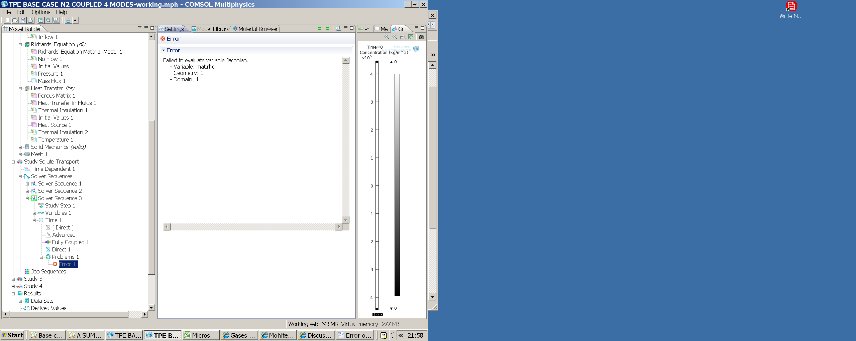

Thanks for the prompt response.

I need help on resolving an error :

Have enabled MATERIALS to use Nitrogen properties.

Even though have "user specified" all the thermal properties of Nitrogen and tried a combination of enable and dissable the above MATERIALS LIBRARY, the error is getting repeated.

Have also entered /added the temperature T in MATERIALS >> BASIS and USER DEFINED, as 248 deg K.

The error does not go away.

Have spent the whole day and now night on this issue.

Regards,

>> Shailendra

July 13, 2010 12:09pm BST
I want to know how to use built-in material property in PDE module
Hello, everyone
it's simple question
I simulate some model with PDE
but, i cannot get information from Material tab
For example, Materials -> Argon{mat1} -> Density(rho), Expression : rho(T)
How to use that value in the PDE?
Below is error code
Failed to evaluate expression.
- Expression: mat1.rho
Failed to evaluate variable.
- Variable: mat1.rho
- Global scope
I tried mat1.rho, mat.rho, mod1.mat1.rho .... etc at the expression box in the PDE
but anything works
Thank you
Lee
Reply | Reply with Quote | Send private message | Report Abuse
Ivar KJELBERG
Moderator
July 13, 2010 5:24pm BST in response to Dong seok Lee
Re: I want to know how to use built-in material property in PDE module
Hi
There are a few caveat with library materials. One is that they are often derived with internal variables such as temperature T and pressure p, and often you do not use these variables by default in your model.
Then you MUST define a Constant T=20[degC] or whatever fits you, and p=1[atm]. I believe you do not have any T defined, or did I miss the point ? (that error is at least a common one).
Next, is that when you define a material from the library, COMSOL 3.5a defines variables "mat1.something" "mat2.something" etc. and set the different (sub)domains material properties equal to the relevant "mat1.something" etc.
So either you use the domain definition through COMSOL or you access the "mat1.something" directly (but this is depending on the order you used to call them into the model.
in anycase you have a rho(T) required so T must be defined, if not through the application mode, than as a Constant
Good luck
Ivar

